**RS**

RICE SHOWER

***Thieves Racer***

***GAME DESIGN DOCUMENT***

**SUMMARY**

1. **Design History………………………………………………………………………………4**

1. **Vision Statement**…………………………………………………………………………..5
   1. Game logline…………………………………………………………………………...5
   2. Gameplay Synopsis..............................................................................................5
2. **Audience, Platform, and Marketing.........................................................................6**
   1. Target Audience...................................................................................................6
   2. Platform.................................................................................................................8
   3. System requirements............................................................................................9
   4. Top performers.....................................................................................................9
   5. Feature comparison............................................................................................17
3. **Legal Analysis.........................................................................................................19**
4. **Gameplay.................................................................................................................20**
   1. Overview.............................................................................................................20
   2. Gameplay description.........................................................................................20
   3. Controls..............................................................................................................24
      1. Interfaces..................................................................................................24
      2. Scoring/winning conditions........................................................................35
   4. Levels.................................................................................................................35
   5. Flowchart............................................................................................................36
5. **Game Characters.....................................................................................................38**
   1. Characters design...............................................................................................38
   2. Types..................................................................................................................38
      1. PCs...........................................................................................................39
      2. NPCs.........................................................................................................39

1. **Story.........................................................................................................................43**
   1. Synopsis.............................................................................................................43
   2. Complete story....................................................................................................44
   3. Backstory............................................................................................................45
   4. Narrative devices................................................................................................46
   5. Subplots..............................................................................................................46
   6. Storyboard..........................................................................................................47
2. **The Game World......................................................................................................50**
3. **Media List.................................................................................................................54**
4. **Prototype..................................................................................................................55**

**TEAM MEMBERS**

|  |  |
| --- | --- |
|  | **Lin Liya**  Game Design  UI Design  Gameplay programmer  [liya.lin@studenti.unimi.it](mailto:liya.lin@studenti.unimi.it) |
|  | **Aragon McAyrton**  Art  Video editing  AI  [mcayrton.aragon@studenti.unimi.it](mailto:mcayrton.aragon@studenti.unimi.it) |
|  | **Chen Xiao Oscar**  Game Design  Technical Design  Programming  [xiaooscar.chen@studenti.unimi.it](mailto:xiaooscar.chen@studenti.unimi.it) |

**1. DESIGN HISTORY**

|  |  |  |
| --- | --- | --- |
| Oscar | 21/03 | Setting document’s layout |
| Oscar | 22/03 | Edit cover |
| Oscar | 23/03 | Edit cover |
| Oscar | 25/03 | Added team logo |
| Oscar | 26/03 | Summary and links |
| Oscar | 28/03 | Edit team members |
| Oscar | 29/03 | Edit team members |
| Oscar | 30/03 | Edit team members |
| Oscar | 5/04 | Edit chapter 3 |
| Oscar | 6/04 | Edit chapter 3 |
| Oscar | 7/04 | Edit chapter 4 |
| Oscar | 8/04 | Edit chapter 3 and 5 |
| Oscar | 11/04 | Edit chapter 2 |
| Liya | 13/04 | Edit chapter 5 |
| Liya | 14/04 | Edit chapter 5 |
| Liya | 15/04 | Edit chapter 5 |
| Liya | 21/04 | Edit chapter 6 |
| Liya | 23/04 | Edit chapter 6 |
| Liya | 29/04 | Edit chapter 7 |
| Liya | 3/05 | Edit chapter 7 |
| Liya | 4/05 | Edit chapter 7 |
| Liya | 5/05 | Edit chapter 7 |
| Liya | 11/05 | Edit chapter 8 |
| Liya | 13/05 | Edit chapter 8 |
| Oscar | 16/05 | Edit chapter 9 |
| Liya | 17/05 | Edit chapter 10 |
| Oscar | 18/05 | Review document |
| Oscar | 19/05 | Review document |
| Oscar | 20/05 | Edit chapter 3 |

**2. Vision Statement**

Thieves Racer is a 3D RPG adventure game for single or co-op multiplayer in which the player controls a character inside the faraway world of Teyria, which is made of 7 islands to explore and complete by defeating every levels and freeing the goddess. The character will gain experience and power-ups in order to survive and defeat more and more difficult levels. The enemies are mostly pirates that have invaded and conquered each island. The player will have to explore each island, talk to various characters he met and obtain better equipments to defeat the pirates. Other players can join the game via online co-op so they can help each others and share experiences and rewards.

**2.1 Game logline**

*Race through the 7 seas.*

**2.2 Gameplay Synopsis**

The goal of the game is to unlock and complete all the levels of each one of the seven maps (islands) available. The main challenge is to at least survive and beat every level of the game, and this is only possible if the player keeps upgrading the character he’s controlling. At the end of each level, the player will receive an amount of rewards which consists of in-game currencies and other items to be used for upgrades. The amount of rewards depends on the performance of the player (remaining HP, number of enemies killed, number of coins collected, …), other items can be unlocked directly from the game shop. There is one shop on each island where the player can make purchases or upgrade his equipment. A better equipment gives a better chance of surviving in the middle of the battle.

Across the map there are various NPCs with which the player can interact directly to obtain useful informations about the game and making easier for the player to continue the adventure.

**3. Audience, Platform, and Marketing**

Developing a good game today can require a lot of time and resources, especialy online games, where the developers have to work constantly to bring new updates the game with new contents, managing feedbacks and fixing a lot of bugs. What we do is to create a simple online game that will run on smartphones and maybe later also on desktops and consoles.

**3.1. Target Audience**

The game we created is meant to be mantained for as long as possible in order keep the players playing at the game. We plan on releasing constantly new contents to the game without changing the entire game structure. Every game has its own target audience that depend on the type of gamer and platforms that on which the game will run. This game in particular is addressed to the young mobile gamers with a lot of free time and a little financial independence, but of course the ideal target could be anyone.

There are various type of players that can be divided by different parameters like age, geographical location and player types for example.

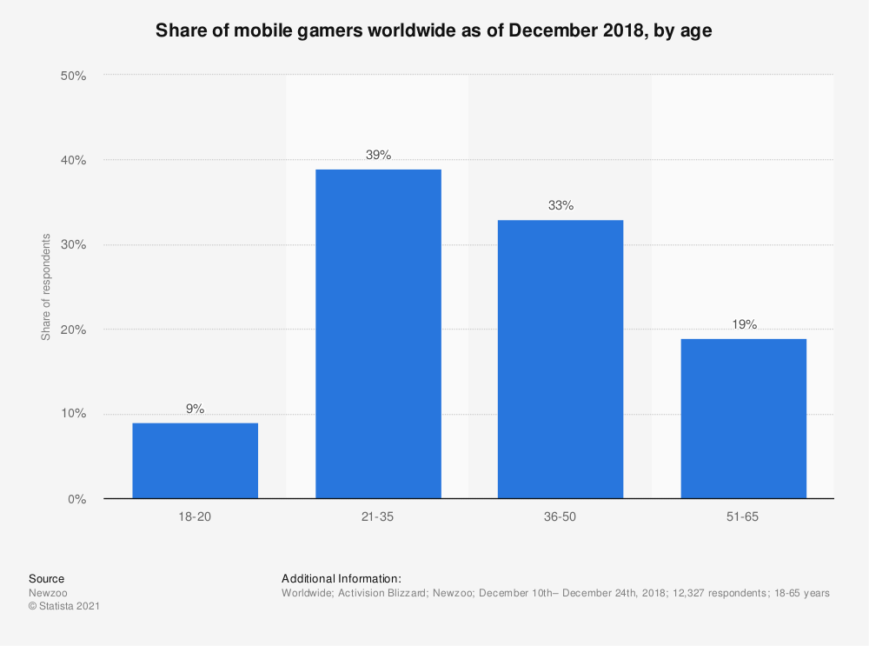**AGE**

It’s not a surprise that many mobile gamers come from the young generations since they have access to the latest tecnology and a lot of free time to spend in playing games, but of course they also expect a lot of quality from the content and a good service in general. They also spend a lot of time with friends to play games together through online co-op sessions or streaming their own gameplay. There are so many social influencers who spend a lot of time playing games and at the same time give their own impression of the game. Many players learn about a new game thanks to them.

**GEOGRAPHICAL LOCATION**

This also is to be expected since half of the world’s population is concentrated in Asia and many big gaming companies are located in those areas. The gaming market over there is quite competitive and we’re not expecting to become big anytime soon. We’ll release our game globally anyway and update the game with new contents and features. Only time will tell us which direction we should be moving forward.

In order to keep the game alive for as long as possible, is also essential to build a community base and carefully observe how the players are experiencing the game. It’s important to keep communicating with the players through social networks such as Discord, Youtube, Reddit, Twitter…

**3.2. Platform**

**HARDWARE PERFORMANCE**

First impressions are important to attract new players to the game. This usually depends on the artworks of the game such as graphics, soundtracks and storyline, but in order to experience better these kind of elements, it’s also important that the game is running (possibly) on a good performing hardware. There are different kind of platforms on which the game can be played but they are all updating their component at a fast rate, almost every year, especially mobile smartphones, tablets and even desktop computers.

The PC platform is still the most preferred platform today, especially in the recent years there is a growth in the home entertainment industry and many people have grown a interest in building their own desktop set up for both gaming and working purposes. Today’s smartphones are performant enough to even be compared to PCs and yet they don’t need any set up and can run decent games that can be played at any moment.

**3.3. System requirements**

The game will run on mobile smartphone with possibly the latest versions of iOS and Android. An internet connection will be required to play the game.

**3.4. Top performers**

**Azur Lane**

|  |
| --- |
|   **Developer:** Manjuu, Yongshi  **Publisher:** Yostar Limited, X.D. Global, Bilibili, Yostar  **Platform:** Android, iOS  **Initial release date:** May 25, 2017 |

Azur Lane is a side-scrolling shoot 'em up, simulation and role-playing video game. Players collect characters that are moe anthropomorphic interpretations of World War II warships ("shipgirls"), mainly from the United States Navy, Royal Navy, Imperial Japanese Navy and Kriegsmarine, with other ships from the French Navy (both Vichy and Free France flavors), Republic of China Navy, People's Liberation Army Navy, Regia Marina, Soviet Navy, Imperial Russian Navy, and Imperial German Navy being added later. Players organize them into fleets of six and confront AI-controlled enemies or other players' fleets. These ships can gain experience points (EXP) from various methods (such as from battles, completing commissions, or placing these ships into Dormitories), and they require a certain amount of EXP to gain a stronger level. They have a certain maximum level limit on how far players can level up their ships, which can be increased via Limit Break. Most characters have their own set of 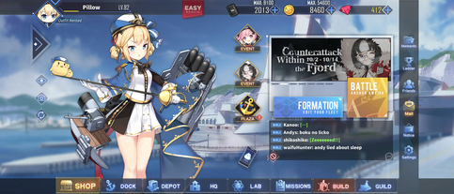upgradable abilities that can be activated in battle.

When preparing for the game's main mode, players can organize two fleets (as the game progresses, they will unlock up to a maximum of 6 fleets) consisting of a front row and a back row, with three slots available in each row. Destroyers, light cruisers, and heavy cruisers can be allotted to the front row, while the back row is reserved for battleships, aircraft cruiser, monitors, repair ships, battlecruisers and aircraft carriers.

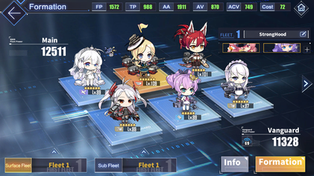Different combinations of ships are required to achieve victory in different battle situations. Players may then select and enter a map.

On entering a map, the player's fleet is placed on a grid-like map similar to that in the game Battleship. The map contains nodes, which are either combat nodes which are enemy fleets, some immobile and others that pursue the player, or non-combat nodes which provides ammunition or mystery nodes which can provide supplies such as repair kits, upgrade materials or can spawn a special combat node called a Treasure Fleet. Players must navigate optimally and assemble their fleets tactically, to clear obstructing enemies and, using minimal movements, reach the map's boss. When the player moves their fleet across the map, they can be ambushed in random encounters from which they may take damage, or they can be forced to engage the enemy, using fuel and ammo. Fuel is one of the two in-game resources. Ammo points are assigned to player fleets at each map, with one ammo point deducted at each battle. Fleets that run out of ammo can still fight but may only deal half damage.

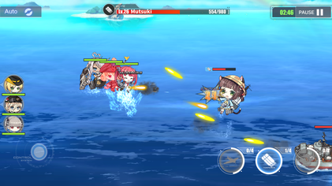**Battle interface of Azur Lane**

When battling an enemy, players can use a virtual joystick to control the front row, which can automatically fire shells at targets and manually launch torpedoes. While stationary, the back row can send shell barrages and the player can manually call in airstrikes. These will activate a bullet-clearing effect, removing all projectiles and torpedoes on screen. Players have an auto mode option to give up this control to the game's AI. Characters' health is fully replenished when completing or exiting a map. Morale points are deducted for each fleet character in a battle. Should a character fall in battle, they cannot join in further action on the map and a larger number of morale points are deducted for the fallen character at the end of the battle. Sustained low morale for a character decreases their stats and affection points. Low affection points lead the character to greet the player with vocals reflecting their disappointment.

The game features a player versus player mode. The player may prepare a defence fleet and organize an offence fleet to challenge opposing players' defence fleets. In this mode, battles are controlled entirely by AI, and the bullet-clearing effect of airstrikes is disabled. Tokens can be gained and the player's ranking can rise through victory in this mode. Players receive no penalty if they lose a challenge or their defence fleet is defeated by other players. Exclusive characters and other items can be obtained using tokens (which is called Merits). The ranking is refreshed every 15 days.

**CUPHEAD**

|  |
| --- |
| **Shape  Description automatically generated with low confidenceDeveloper:** Studio MDHR  **Publisher:** Studio MDHR  **Platforms:** Nintendo Switch, PlayStation 4, Xbox One, Microsoft Windows, macOS  **Initial release date:** September 29, 2017 |

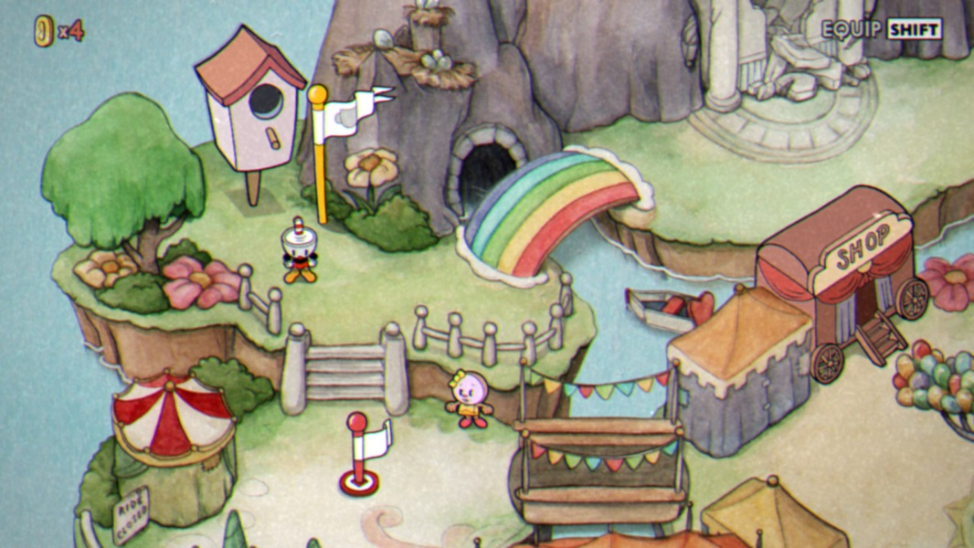Cuphead's gameplay is centered on continual boss fights, interspersed with run-and-gun levels. Each is housed in one of four worlds, with the final fight against the Devil. Each boss fight includes a simple, normal, and expert difficulty mode (with the exception of the final two bosses, which lack a simple mode). Defeating every boss on normal mode is required to complete the game, and expert mode is unlocked upon completion. Most boss battles take place on land, although some have the player piloting an aeroplane and play like a side-scrolling shoot 'em up. The game includes role-playing elements and a branching level sequence. Player characters have infinite lives, maintaining all equipment between deaths. Equippable weapons and special abilities known as Charms can be purchased from Porkrind's Emporium, an in-game shop, using coins found in levels and the overworld. Player characters can use a slapping parry attack on objects marked in pink to various effects, the most important of them being increasing a super meter that enables more powerful attacks. The super meter is represented by a row of five playing cards, all of which must be filled to use one of the three strongest attacks ("Super Arts") in the player's inventory. A less powerful strike can be executed at the cost of one card, its particular form determined by the currently equipped weapon. The Super Arts are earned by entering three mausoleums, one in each of the first three worlds, and parrying a group of invading ghosts to stop them from reaching an urn at the center of the screen.

After completing a level, the player is ranked with a grade based on performance, based on factors such as the time taken to complete the level, damage avoided, and number of parried attacks. The levels are accessible through a top-down perspective overworld with its own secret areas. The game has a two-player local cooperative mode, in which either player character can return to the game after being killed if the other one parries his soul before it rises off the screen. Cuphead's brother, Mugman, acts as an alternative skin and potential co-op partner within the game.

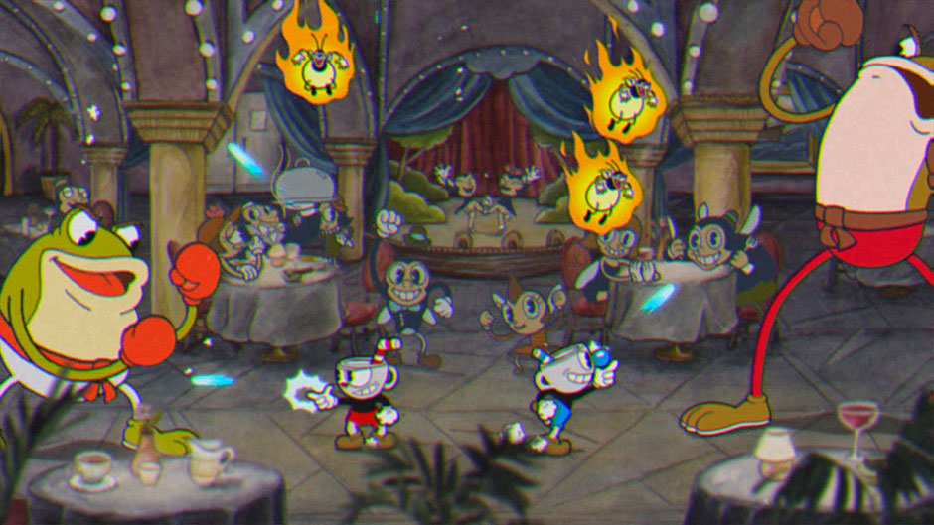

**GALAGA: WARS**

|  |
| --- |
|   **Developer:** Paladin Studios  **Publisher:** Bandai Namco  **Platform:** iOS, Android  **Initial Release:** June 10, 2016 |

Galaga: Wars is a take on the classic 1981 arcade game Galaga for mobile devices. It consists of several levels called sectors where waves of enemies need to be defeated in a vertically scrolling environments. The space ship fires automatically and it can be moved around anywhere on the screen by tapping, holding and dragging it. As soon as the player releases the finger the game is paused.

Initially only the Fighter ship from Galaga is available. The game is free-to-play, but additional ships can be bought through an in-app purchase. There is FX-01 from Starblade, Galaxip from Galaxian and Solvalou from Xevious. Defeated enemies leave behind power-ups that are unique for each ship, except for the one that briefly provides a faster firing rate. The Figher ship for instance has access to a coin magnet, a jumbo shot, a missile barrage and a turret, while FX-01 can briefly become invulnerable through a ghost form, Galaxip has ricochet bullets and Solvalou has a ram shield to destroy enemies. Defeated opponents also leave behind coins that can be used to upgrade each power-up multiple times to enhance the effects. Sometimes a captured ship can be freed and then it briefly acts as a wingman, copying the main ship's movement and firing.

Sectors generally end with a boss or a wave very reminiscent of the original Galaga. The scrolling environment is changed into a fixed-screen one and a large wave of enemies appears near the top in rows as in the original game, with ships swooping down quickly. After completing sectors there is sometimes a bonus flying section where additional coins can be picked up, shown from a behind view. The ship only has one life, but an additional one can be earned by spending coins or watching a video advertisement. An in-app purchase can also provide a coin doubler. Enemy ships drop warp modules. Once a sector is completed, it can be accessed right away, skipping the earlier ones, by spending these modules.

|  |  |
| --- | --- |
|  |  |
|  |  |

**3.5. Feature comparison**

|  |  |  |  |  |
| --- | --- | --- | --- | --- |
| **Title** | **Thieves Racer** | **Azur lane** | **Cuphead** | **Galaga: Wars** |
| **Genre** | RPG | RPG | Platformer | Arcade |
| **Graphics** | 3D | 2D | 2D | 3D |
| **Platform** | Mobile | Mobile | PC/Console | Mobile |
| **Engine** | Unity | Unity | Unity | Unity (?) |
| **Offline mode** | Single player | No | Single player or co-op | Single player |
| **Online mode** | Co-op Multiplayer | Single player and PvP | No | No |
| **Story** | Yes | Yes | Yes | No |
| **Character upgrade** | Yes | Yes | Yes | Yes |
| **Interactable map** | Yes | Yes | Yes | No |
| **In-game shop** | Yes | Yes | Yes | Yes |
| **Multiplayer** | Yes | Yes | Yes | No |
| **Character control** | In-game joystick | In-game joystick | Keyboard/  Joystick | Touch Controls |
| **Require internet connection** | No | Yes | No | Yes |

Thieves racer has very similar features with other competitors. The game aims to deliver a good graphic quality on par with his competitor and at the same time delivering a fun and addictive experience for as long as possible. The online mode offer the possibility to share the game eperience with another remote player.

Although the game mechanics are nothing new, since they are heavily inspired by other RPG games. These type of games require a very long gameplay time in order to complete the whole story and quests. In order to make the gameplay time longer, there are various features added for this purpose: for example the upgrade system was designed to add more goals, and in this way the players are forced to play a little longer to complete the game. Other systems to increase gamplay time involves in adding side-quests and new events every once in a while through updates.

**4. Legal analysis**

Thieves Racer is made entirely with Unity. The names of the characters do not refer to any particular person or event in real life. The artworks are created by using assets components retrieved from the assets store.

The game contains in-app purchases and may cause gambling addiction.

**5. Gameplay**

**5.1 Overview**

In a ancient land composed by 7 island where every island was protected by a goddess, an army of bad pirates appeared, people were subdued to the power of this army, once every island lose the battle, the darkness won and the won’t be peace anywhere. After they conquered the sixth island, the last goddess of the last island summoned a hero (the player), the future of the land is in this person’s hand.

**5.2 Gameplay description**

There are 2 playable mode, offline and online.

**Offline**

Doesn’t require an internet connection to play and everything will be stored locally (not by playerprefs).

**First time log in**

If it is the first time the player log in, he will be asked to insert a name and after that automatically enter the tutorial.

**Tutorial**

The tutorial will introduce the story before the character arrived in Teyra land and will teach the player the basic commands to move the character.

**Normal**

If it’s not the first time, after the player staarts the offline mode, the player will be sent to the world of Teyra, where he can move the character and decide to do whatever he wants like fighting enemy or collecting money, spend money in a shop to buy new ships, upgrades or to interact with the NPCs. There will be a total of 7 islands available, every island with its own story, dialogues, equipments and enemies, and the player has to clear the story of the island, before moving to the next one.

**Story and battle**

To progress with the story, the player must fight the enemy, once the player is near to an interactable object such as the enemy, he can interact with it, it will show a description menu with the stars achieved and 2 options: start the battle or back.

In some battle, there will be a dialogue that activates at start or when the boss is about to appear. It is used to start an event, for example a battle where we got ambushed, or it will give an advice or hidden tip for some strong enemies.

**Dialogue**

If a player is near a dialogue NPC such as goddess, the interact will be active and he can open a dialogue with the selected npc, there will be multiple choice in the dialogue which will lead to different answer from the npc, to discover every little thing, you need some more talk.

**Reward and win**

When the player wins, they will be rewarded with in-game currencies to be spent in the game shop.

**Lost**

If the player loses he can chose to restart the game or go back to the map.

**Shop**

The shop is an interactable building, when th player interact with the shop, it will appear a window and show the the available items.

**Upgrade & inventory**

When the player buys a new ship, this will automatically update to other system, such as upgrade and inventory system.

The upgrade system is a gameObject house which is the same as the shop, the difference is that it will show the stats of the ship and eventually give the player the possibility to upgrade it by spending money.

The inventory is a button, when clicked it will show the item bought from the shop and its current stats and give the functionality to switch to a different ship to be used in battle.

**Currency**

There are only 2 ways to obtain the game currency: defeating the enemies, since the level can be repeated and you will always get reward after clearing it; or you can directly fill the cash through in-app purchase to obtain the game currency.

**Map**

When the player beat all the enemies in the map at least once, he will unlock a new map, to move around the map we have a ship set up in the map which allow our player to travel around available maps. Once you are near the travel ship, it will automatically activate the interaction with player, and player can chose to switch map or stay in the current map.

**Ending**

The game is cleared when the player successfully beat the last enemy pirate and set free all islands in Teyra.

After this, there will be opened a challenge stage, which is a level where the enemy will appear endlessly with increasing difficulty.

**Online**

The online mode can be played both by single player or 2 players. Every function descripted above also work for online mode except for dialogue, map menu and enemy interaction.

**Difference between online and offline mode**

The goal of this game is similar to Cuphead, you can play and enjoy the story alone, but you can also clear it and enjoy the story together with a friend, and the difference is:

**-** **Dialogue system:** if a player starts a dialogue with a NPC, the other one starts the same dialogue at the same time, if a player choses an option, the other one get the same choices and consequences.

**-** **Switch map:** if a player switched the map, both players switch to the same map.

**- Enemy interact:** if a player opens the enemy menu, both players open the same menu, if one of them press start battle, both player will be automatically sent to the battle to fight together.

After beating all levels you can also play the challenge stage with your friend.

**5.2.1 Game mechanics**

**Walking**

The player can move by using the joystick in the screen

**Interact**

Once the player is near any interactable object, the interaction battle will activate and change its icon to the corresponding object system, if the player clicks on it, it will activate the interaction on that element. The interactable systems are: shop, upgrade, dialogue, enemy, switch map.

**Inventory**

Every player got an inventory, which display the current ship and other available ships for battle, the player can choose the ship he want to use fo battle.

**Switch map**

It allow player to switch around the island.

**Goddess blessing**

When the player completes an island and frees the locked goddes, she will bless the player and grant him a skill to use during battle.

**Final strike**

Each ship has a unique special attack called ‘Final Strike’.

**Battle**

When a battle start, the enemy will be spawned per round until the last one (boss).

**5.3 Controls**

The game runs on mobile platform, so the player will interact with a virtual touch joystick to move the characters, ships and everything else.

**5.3.1 Interfaces**

The interface in the game are Menu, Joystick, interact button, inventory, upgrade, shop, dialogue, credits, tutorial, character customization, settings.

All interfaces shown down below are for illustration purposes, some of them will be kept after the release and others may change.

**Opening screen**

When the player launches the game, the first screen showed is the opening scene with a fader after around 5-6 sec it will fade and send player directly to the scene where he chose the game mode, in this scene we have the team logo, version number and the game name plus a background image, the player don’t need to do anything here. This is used as splash screen but, if it is the first time, the player will be sent to the tutorial scene.

**Menu scene**

The menu scene is quite simple, the player have 4 choice, to play offline, host, join or change the settings. In the settings the player can change his preferences, such as languages and sounds.

**Game Interface**

The game interface offer the player the most important functionality to play the game, such as character control with joystick, interact button (without this you almost can do nothing) and the inventory.

In this case the interact is start a dialogue.

The game interface also include charge cash button, current money display, menu button for back to the previews scene.

**Pause or setting menu**

You can back to the default scene which you can chose the offline or online mode.

**Cash charge UI**

This interface will allow the player to fill in-game currecies through a real purchase with real money. This is usually the way the developers earn from their games.

**Inventory UI**

The inventory is used for selecting the ship to be used in the battle, once you open it, you can see its current configuration, such as upgrade status, unlocked ships, locked ships.

**Shop UI**

The shop ui is used to unlock new ship by spending game currency, it is made by using a scroll rect and grid layout group.

**Upgrade UI**

This can be considered the most challenging ui to be created.

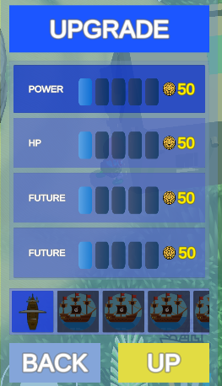

**Dialogue UI**

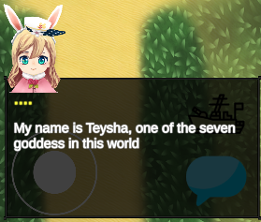Once the player start a dialogue, the dialogue UI will show up, the current person’s name is displayed, the default name is “…”.

In this case, after the speaker says its name, it will appear as its name.

There are also multiple choice sections.

The dialogue will end once you get out the information needed. Since this interface is offline, the online one will be slightly different, it will give the player one more choice, to close the conversation because maybe the friend you invited is ahead of you and don’t want to see the conversation again.

**Enemy UI**

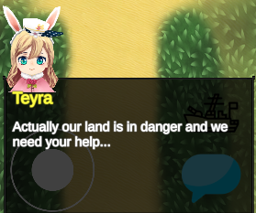When you are near an enemy the interaction icon will change and gives you the option to interact with it.

This UI is made of title, the score which is measured by star, a description and the selection to fight or leave.

**Map switch UI**

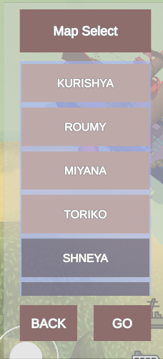In this UI Player can choose the map to switch.

**The battle**

The battle scene consists in a vertical screen which the player can put the game in pause mode. It’s possible to control the ship movement with the virtual joystick, invisible at first and appear after the player touches the bottom left area of the screen.

The goddess skill, which is a unique skill, and the other 7 goddess skills, can be activated by pressing the button with the goddess icon, and after that, the skill will enter on its cooldown, it could be 10s, 20s or more, depending on the skill used. The first goddess’s skill is a healing ability, and each type of skill has different icon.

****The ultimate strike, is a special ability of the ship, there is a unique ability for each ship, this skill can be released after pressing the button with strike icon, there are a lot of strike skill, but it can be classified in 2 categories, destructive, or statistical.

The destructive one increases the offensive capability of the ship by increasing the output damage. The statistical one increases the stats of the ship, like defense, movement speed, average power etc…

**The pause UI**

This interface allows the user to pause the game and then resume the game or quit the scene.

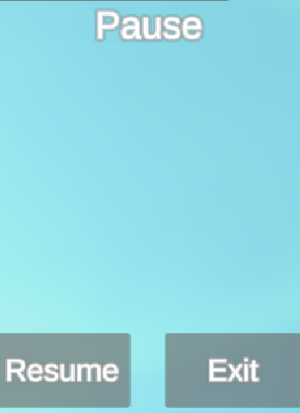

**The win UI**

When the player successfully defeats the boss of the level, it will automatically appear after 4 sec, the time needed for the boss’s death’s effect to end completely.

There is also the ‘retry’ function to let the player play the level again if he want a better score.

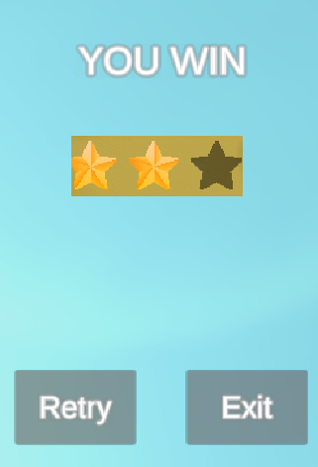

**The lose UI**

If the player lose the battle, it means his HP has gone 0, the interface of ‘lose’ will appear, giving him the choice to retry or quit.



**Cooldown view**

Using one of the two skills available, they will enter in cooldown phase, a period of the time left for the next release.

As shown in the image above, after using an ultimate strike, the skill will enter in cooldown, and when the cooldown reaches 0, the ability can be used again.

The two skills are independent, this means that if the player click on the goddess’s skill, only the goddess’s skill will enter in cooldown, the same for the ultimate strike.

**5.3.2 Scoring/winning conditions**

The winning conditions of the level is intuitive, fight every wave until the boss appear, once you beat the boss you have won the level.

The score is measured in stars which is:

* Time used for clearing the level.
* The damage taken for clear the level.
* The average power of the ship (if is too much powerful it will be too easy to 3*).

**5.4 Levels**

Every level possesses a wave of mobs, there can be different type of mobs, the mobs will move automatically, and then they will attack you. The player always starts in the bottom center of the scene, while the boss always appears at the top center of the scene. The enemies can be spawned in random positions during battles. There will be at least 3 level for each island.

**5.5 Flowchart**

|  |  |
| --- | --- |
| Achievement | Description |
| A smooth start with some prices…. | Charge one time |
| Power of money | Charge 3 times |
| It is easy with the power of cash | Charge 10 times |
| A perfect start | Clear a 3* in one level |
| Nobody is perfect, I’m nobody, so I’m perfect. | Clear a stage without losing hp |
| Such a lovely island | Select all dialogue options with Teysha |
| Such a bravery island | Select all dialogue options with goddess2 |
| Such a give me a break island | Select all dialogue options with goddess3 |
| Such a sad island | Select all dialogue options with goddess4 |
| Such a pain in the island | Select all dialogue options with goddess5 |
| Such a sleepy island | Select all dialogue options with goddess6 |
| Such a difficult island | Select all dialogue options with goddess7 |
| Is it worth to travel? | Select all dialogue with all goddesses |
| The first adventures | Clear the first level |
| The first-time being hero | Clear the first island |
| The first travel into another island | Travel once in another island |
| The first time to buy ship | Unlock 1 ship in shop |
| I’m just too rich or too active | Unlock every ship in shop |
| Do you need power traveler? | Upgrade once one ship |
| This is the max power | Upgrade every stat to max for 1 ship |
| Aren’t you over doing this? | Upgrade every stat of every ship to its max value |
| The start of the legend | Clear the story of the first island |
| The upcoming challenge | Clear the story of the second island |
| The chilling island | Clear the story of the third island |
| The sorrow island | Clear the story of the forth island |
| The painful island | Clear the story of the fifth island |
| Do you still need to be sleepy? | Clear the story of the sixth island |
| I’m the greatest pirates | Clear the story |
| Race through seven island | Obtain every achievement |
| Coming soon…. | …. |

**6. Game Characters**

**6.1. Characters design**

Thieves races is a RPG game, which includes a lot of NPC characters, but the playable characters is currently one.

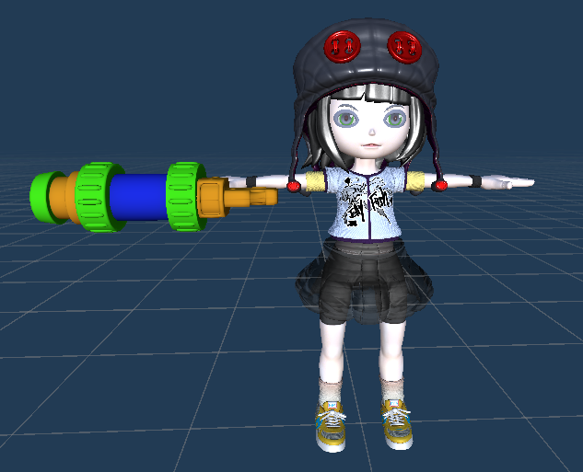

This is the controllable character, it is used for interact with map and system.

**6.1.1 Character’s ship design**

For the moment, there is only 1 character ship available in this document.

|  |  |
| --- | --- |
|  | **Basic information**  **Name:** F21  **Description:** is a handmade ship, the producer is the main character, the number 21 is the number of times he tried building this ship, is not resistant, no high fire power, but have good mobility.  **HP:** 100  **Speed:** 8  **Defense:** 10  **Power:** 10  **Special Ability**  Releases a huge bomb which deal high damage to enemy.  **Damage:** power x 20.  **Cooldown:** 10s |

**6.2. Types**

**6.2.2. NPCs**

The npc are, Goddesses and helper.

**Goddesses**

There are 7 goddesses across the islands who need your help to free the island and its people from bad pirates.

Each one has a dialogue and depending on the situation, she can give you the goddesses bless which is a skill that can help you to overcome some obstacles.

|  |  |
| --- | --- |
|  | **Basic information**  **Name:** Teysha  **Location:** first island  **Personality:** diligent  **Description:** Teysha is the oldest goddesses so probably that’s why she’s so diligent.  **Powers**  **Name:** Healthy field  **Description:** Teysha is named the goddesses of healthy, this skill can recovery any injury, even for ship.  **Effect:** recovery a % amount of ship health.  **Cooldown:** 20s. |
|  | **Basic information**  **Name:** Teywa  **Location:** Second island  **Personality:** bravery  **Description:** Teywa is the tiniest goddesses, she’s audacious and most of the case doesn’t like to listen.  **Powers**  **Name:** Strength Will  **Description:** Teywa is named the goddesses of bravery, this skill can increase the will of people.  **Effect:** increase the damage of the ship.  **Duration:** 10s.  **Cooldown:** 20s. |
|  | **Basic information**  **Name:** Teyfee  **Location:** Third island  **Personality:** Chill, calm.  **Description:** Teyfee’s the 2nd goddesses, she’s island is called the island for rest, probably because of her personality.  **Powers**  **Name:** Sacred rest and chill  **Description:** Teyfee is named the goddesses of chilling, this skill can calm down the people.  **Effect:** decrease the damage of enemy ship.  **Duration:** 10s.  **Cooldown:** 20s. |
|  | **Basic information**  **Name:** Teyma  **Location:** forth island  **Personality:** sorrow  **Description:** Teyfee’s the 3rd goddesses, she’s island is called the island for rest, probably because of her personality.  **Powers**  **Name:** Sacred crying  **Description:** Teyfee is named the goddesses of chilling, this skill can calm down the people.  **Effect:** decrease the %hp of enemy.  **Cooldown:** 20s. |
| Coming soon… | Coming soon… |

**Citizens**

People in the island who are captured by pirates.

**Helper**

People in the island who offer to help you in order to release the island. They give you some suggestion about some specific level.

**Enemy**

The enemy npc is used to start a thieves races battle.

|  |  |
| --- | --- |
|  | **Basic information**  **Name:** the little pirate  **Description:** the enemy’s little ship, low hp, low attack, just for mobs.  **Stats**  **Speed:** 4.  **Power:** 10.  **Defense:** 0.  **HP:** 40.  No special attack. |

**Enemy General**

Actually they are the boss of the island, you need to defeat them, they got more hp and have more attack pattern than the other normal enemies.

|  |  |
| --- | --- |
|  | **Basic information**  Name: The boss  Description: this is a ship used by enemy boss, it has low mobility, but it have high defense and special attack.  **Stats**  **Speed:** 2.  **Power:** 10.  **Defense:** 10.  **Hp:** 2000.  **Special attack**  **Huge bomb:** release a huge bomb, with medium/low radius.  **Cooldown:** 5s.  **Damage:** power x 4. |

**7. Story**

**7.1. Synopsis**

**A short summary**

In an ancient era the world was populated by pirates, which were known as sea explorers with their extraordinary and resistent ships, they survived the sea with their strength. A child who admires them decided to became the greatest pirates of the world, so she started to build her own ship and started her first adventures, but unfortunately, she encountered a group of bad pirates, very different from the ones she admired, who destroyed her ship and almost got her fall into the ocean. Just before she lost her consciousness she heard a voice telling her to "not give up and keep fighting for her dream", and when she woke up, she found herself in an island and a goddess appeared in front of her, who told her that she was summoned in this land named Teyra, a peaceful land which everyone could enjoy a fair life, but suddenly, out from nowhere, an army of dark pirates appeared, challenging people with "thieves races", a dangerous battle where the loser must give up everything. The goddess says that she was summoned because she seems to possess a strong ambition, with a brave and kind heart, and asked her to free the island and her other goddesses. In the meantime, the pirates army arrived to this island, and she immediately decided to help the goddess, and started fighting the pirates, and with the help of the goddess she managed to survive.

After that she was told the current situation: Teyra have 7 island ruled by 7 goddesses, every goddess possesses a unique kind of power, but they can't directly join to the battle, all they can do is give some support, like the goddess blessing. If every warrior on the island fall, the pirates will win and will rule the island. Actually they’ve already conquered 6 islands, so if they conquer this last one, they will manipulate the land of Teyra as they like, so again the goddess begged the (lost) traveler to save this land. The traveler accepted to help the goddess and started her journey around Teyra.

She managed to travel around all the seven islands: Kurishya, Roumy, Miyana, Toriko, Shneya, Meisha, Kurishya, met every goddess, fought the pirates’ army and their generals.

After a long journey full of surprises and dangers, she finally managed to free the land from pirates and from that moment she was known as the hero of Teyra.

**7.2. Complete story**

**7.2.1 Act1**

You were summoned by the goddess in the island, who asked for your help, in the meantime you were told what’s going on, the enemy pirates landed on the island and challenged you to a cruel duel ‘thieves race’, a battle where the loser has to give up everything. You had no choice so you accepted the challenge, and the enemy is well prepared to destroy you, because they are really strong than you imagined, and just when the situation is getting worse, the goddesses offered her bless to you, which is a healing abilty, because she can heal everything that exists in the land, so with her help you managed to defeat the pirates, after that the goddesses explained the situation of this world, an army of dark pirates appeared out of nowhere and conquered 6 islands over 7, so she asked you to help her to free the other islands and the goddesses, you accepted this request and started your journey.

**7.2.2 Act2**

In the second island Roumy you encountered the 2nd goddesses, a very young one, Teywa, she’s a brave goddesses, she want to free the people of the island as soon as possible, so she joined you. The pirate general of this island is well known for his endurance because his defensive ship is really hard to pierce even against other generals, but has a weak spot, which was caused by the previous battle on the island, against the previous warrior of the land, who unfortunately has fallen after that. So you were provided with this information and rushed to challenge the general, and with the help of the goddesse’s blessing, which can increase hugely the ship’s damage, you manage to defeat the general and free the second island.

**7.2.3 act3**

In the third island Miyana you encountered Teyfee, the goddess of the third island with a very beautiful voice. This island is currently controlled by the most aggressive general of the pirates army, and Miyana is a very peaceful island. In fact there is almost no presence of pirates in this place, but you still need to free this place from them and finding the general is very hard to find.

Thank to the information gotten from a citizen you finally found out where the general is and challenged him to the battle. Once again you received assistance from the godess, which has the ability to manipulate the enemy’s aggressivness, and in this case the general’s damage were reduced. In the end you beat the general and ready to go to the next island

**7.2.4 act 4**

After landing on the Toriko island, which is called the land of sorrow, there are very few people living here. The pirates immediately captured this spot, since they didn’t encounter any resistance. But once you started challenging them, the goddess came into your help by reducing the enemy’s moral and they are forced to retreat.

**7.3. Backstory**

The Teyra land is governed by the supreme god which dictate the rules of this entire world, and in order to maintain these rules, every island have a goddess who protect the island the people who live in. In this way his power is shared between the seven godesses so no one can prevail on the others.

**7.4. Narrative devices**

The story is told mainly through dialogues with NPCs and the player enters the battle scene, if there is a story directed in that battle scene, he will start the dialogue. The same thing happen when the boss appears.

**7.5. Subplots**

When every island has lost their best warrior, the goddesses would be submitted to the pirates, this means that she can’t oppose to the will of pirates, so if the pirates successfully submit all goddesses they can change the world rules as they want.

**7.6 Storyboard**

|  |  |
| --- | --- |
| **1. Cinematic**  In a ship battle, the main character got hit and fell into the ocean. | **2. Cinematic**  A hand and a voice appeared out of nowhere before the main lose consciousness. |
| **3. Gameplay Starts**  The main woke up and find herself in a island. The only thing she remember is she was saved by someone, then there is a path in front of her. | **4. Gameplay**  Along the path there was a goddess waiting her, the goddess saved the traveler and summoned her in this world. |

|  |  |
| --- | --- |
| **5. Cinematic**  The enemy appears in the scene while she was talking to the goddess, it seems she has no choice but to fight them. | **6. Gameplay**  The player will control a ship, which can move in the entire scene and automatically shot, the enemies are also ships and will try to destroy you. |
| **7. Gameplay**  The player killed all enemy mobs. | **8. Gameplay**  The enemy boss appears. |

|  |  |
| --- | --- |
| **9. Gameplay**  The boss is more stronger, and almost killed you, but the goddess appears and gave you her bless, an ability which can repair anything, and you use it to cover your damage. | **10. Gameplay**  After a long battle, you use your ultimate hidden strike, which can deal huge damage to enemy, and finally you managed to defeat the boss. |
| **11. Cinematic**  After you cleared the first level the goddess told you about their situation, and asked for your help. |  |

**8. The Game World**

The entire game is set in the land of Teyra, which is a world made of 7 islands, each one has a different culture. Before the invasion, it was a peaceful and beautiful world. It was a peaceful world ruled by 7 goddesses, most people were all citizens, and each island have only few warriors. When the army of pirates showed up, they attacked multiple islands at once, and they succeded conquering 5 islands immediately. When they almost conquered the sixth island, the goddess of that island sent a messenger to the last one, who decided to summon a hero from another world in order to save Teyra.

**World map**

The map is an island, which the main character can move and interact with. The size is medium/little, because bigger map will lead to confusions and problems remembering the path, while a smaller one is easier.

**Settings**

By default, each map has:

* One goddess.
* A building for shopping.
* A building for upgrades.
* Several enemies to interact.
* A start location.
* A ship for travelling to another island.
* Several NPCs.

**Kurishya**

This is just a template of the first island, the prototype one may be different.

**Roumy**

Second island.

**Miyana**

Third island.

**Toriko**

Fourth island.

**Level map**

Almost all level will follow the same structures:

- At the start the mobs will spawn at the top part of the screen.

- The player will appear at the bottom of the screen.

- When the player has killed all the mobs, the boss will spawn at the middle top of the screen.

- The number of enemy spawns, the strength of the boss depend on the level.

****- There may be some level where there will be debuff on player depend on the kind of ship he chose.

**9. Media List**

|  |  |  |
| --- | --- | --- |
| **GROUP** | **MEDIA TYPE** | **DESCRIPTION** |
| **Game Application** | Image | Application logo |
| Splashscreen background |
| **Menù** | Image | Background |
|  | Sound | Menù music |
| **Enviroments** | 3D models | Main character |
| Goddess 1 |
| Goddess 2 |
| Goddess 3 |
| Goddess 4 |
| Goddess pet |
| Common battleships |
| Elite battleship |
| Map |
| Shop |
| Buildings |
| Enemies |
| Plants |
| Dialogues | Dialogues with NPC |
| **Music** | Soundtrack | Map |
| Battle |
| SFX | Attack sound |
| Special attack sound |

**10. PROTOTYPE**

The prototype 2d, 3d art may be different.

The menu setting features will be empty.

The prototype will have online and offline features.

**Offline:**

* 4 map to interact, but only the first one have all features.
* 1 level to play.
* 1 boss only.
* 1 type of mobs.
* 1 Npc to interact with dialogue which is the goddesses.
* 1 dialogue with the goddess.
* 1 goddess skill.
* 1 ultimate strike.
* There is shop, upgrade, inventory system but there will be only 1 ship available to play, and these functions are only simulated.
* All the ui features excluding the above ones.
* Enemy movement are all naïve.
* Enemy damage is naïve.

**Online:**

* 1 map to interact with its features.
* 1 level to play.
* 1 boss.
* 1 type of mobs.
* 1 Npc to interact with dialogue which is the goddess.
* 1 goddess skill.
* 1 ultimate strike.
* Enemy movement is naïve.
* Enemy damage is naïve.
* Shop, upgrade system are available but there will be only 1 ship available to play, inventory is not finished yet.
* The linking from chooses level and battle scenes, this means these 2 systems can only be tested separately.
* To interact with the goddess, 2 players must be both close to the npc.
* To interact with enemy, 2 players must be both near the enemy.
* In battle scenes, the ‘retry’ function is not yet implemented.
* Level score system.

What online mode doesn’t have in prototype:

* Battle win UI.
* Battle lost UI.
* Battle pause UI.
* Replay battle function.
* Quit battle function.
* No connection between level selection and battle selection, the battle online and level selection online features need to be tested separately, there will be a button on the right screen in the opening scene to access the battle online scene.
* Disconnection management.